**Homework 5**

**Question 1: Design a synchronous BCD counter using JK flip-flops**

|  |  |  |  |  |  |  |  |  |  |  |  |  |  |  |  |
| --- | --- | --- | --- | --- | --- | --- | --- | --- | --- | --- | --- | --- | --- | --- | --- |
| QA | QB | QC | QD | QA+ | QB+ | QC+ | QD+ | JA | KA | JB | KB | JC | KC | JD | KD |
| 0 | 0 | 0 | 0 | 0 | 0 | 0 | 1 | 0 | x | 0 | x | 0 | x | 1 | x |
| 0 | 0 | 0 | 1 | 0 | 0 | 1 | 0 | 0 | x | 0 | x | 1 | x | x | 1 |
| 0 | 0 | 1 | 0 | 0 | 0 | 1 | 1 | 0 | x | 0 | x | x | 0 | 1 | x |
| 0 | 0 | 1 | 1 | 0 | 1 | 0 | 0 | 0 | x | 1 | x | x | 1 | x | 1 |
| 0 | 1 | 0 | 0 | 0 | 1 | 0 | 1 | 0 | x | x | 0 | 0 | x | 1 | x |
| 0 | 1 | 0 | 1 | 0 | 1 | 1 | 0 | 0 | x | x | 0 | 1 | x | x | 1 |
| 0 | 1 | 1 | 0 | 0 | 1 | 1 | 1 | 0 | x | x | 0 | x | 0 | 1 | x |
| 0 | 1 | 1 | 1 | 1 | 0 | 0 | 0 | 1 | x | x | 1 | x | 1 | x | 1 |
| 1 | 0 | 0 | 0 | 1 | 0 | 0 | 1 | x | 0 | 0 | x | 0 | x | 1 | x |
| 1 | 0 | 0 | 1 | 0 | 0 | 0 | 0 | x | 1 | 0 | x | 0 | x | x | 1 |
| 1 | 0 | 1 | 0 | x | x | x | x | x | x | x | x | x | x | x | x |
| 1 | 0 | 1 | 1 | x | x | x | x | x | x | x | x | x | x | x | x |
| 1 | 1 | 0 | 0 | x | x | x | x | x | x | x | x | x | x | x | x |
| 1 | 1 | 0 | 1 | x | x | x | x | x | x | x | x | x | x | x | x |
| 1 | 1 | 1 | 0 | x | x | x | x | x | x | x | x | x | x | x | x |
| 1 | 1 | 1 | 1 | x | x | x | x | x | x | x | x | x | x | x | x |

|  |  |  |  |  |
| --- | --- | --- | --- | --- |
| QA QB\QC QD | 00 | 01 | 11 | 10 |
| 00 | 0 0 | 0 1 | 0 3 | 0 2 |
| 01 | 0 4 | 0 5 | 1 7 | 0 6 |
| 11 | x 12 | x 13 | x 15 | x 14 |
| 10 | x 8 | x 9 | x 11 | x 10 |

JA(QA,QB,QC,QD)=QBQCQD

|  |  |  |  |  |
| --- | --- | --- | --- | --- |
| QA QB\QC QD | 00 | 01 | 11 | 10 |
| 00 | x 0 | x 1 | x 3 | x 2 |
| 01 | x 4 | x 5 | x 7 | x 6 |
| 11 | x 12 | x 13 | x 15 | x 14 |
| 10 | 0 8 | 1 9 | x 11 | x 10 |

KA(QA,QB,QC,QD)=QD

|  |  |  |  |  |
| --- | --- | --- | --- | --- |
| QA QB\QC QD | 00 | 01 | 11 | 10 |
| 00 | 0 0 | 0 1 | 1 3 | 0 2 |
| 01 | x 4 | x 5 | x 7 | x 6 |
| 11 | x 12 | x 13 | x 15 | x 14 |
| 10 | 0 8 | 0 9 | x 11 | x 10 |

JB(QA,QB,QC,QD)=QCQD

|  |  |  |  |  |
| --- | --- | --- | --- | --- |
| QA QB\QC QD | 00 | 01 | 11 | 10 |
| 00 | x 0 | x 1 | x 3 | x 2 |
| 01 | 0 4 | 0 5 | 1 7 | 0 6 |
| 11 | x 12 | x 13 | x 15 | x 14 |
| 10 | x 8 | x 9 | x 11 | x 10 |

KB(QA,QB,QC,QD)=QCQD

|  |  |  |  |  |
| --- | --- | --- | --- | --- |
| QA QB\QC QD | 00 | 01 | 11 | 10 |
| 00 | 0 0 | 1 1 | x 3 | x 2 |
| 01 | 0 4 | 1 5 | x 7 | x 6 |
| 11 | x 12 | x 13 | x 15 | x 14 |
| 10 | 0 8 | 0 9 | x 11 | x 10 |

JC(QA,QB,QC,QD)=QA’QD

|  |  |  |  |  |
| --- | --- | --- | --- | --- |
| QA QB\QC QD | 00 | 01 | 11 | 10 |
| 00 | x 0 | x 1 | 1 3 | 0 2 |
| 01 | x 4 | x 5 | 1 7 | 0 6 |
| 11 | x 12 | x 13 | x 15 | x 14 |
| 10 | x 8 | x 9 | x 11 | x 10 |

KC(QA,QB,QC,QD)=QD

|  |  |  |  |  |
| --- | --- | --- | --- | --- |
| QA QB\QC QD | 00 | 01 | 11 | 10 |
| 00 | 1 0 | x 1 | x 3 | 1 2 |
| 01 | 1 4 | x 5 | x 7 | 1 6 |
| 11 | x 12 | x 13 | x 15 | x 14 |
| 10 | 1 8 | x 9 | x 11 | x 10 |

JD(QA,QB,QC,QD)=1

|  |  |  |  |  |
| --- | --- | --- | --- | --- |
| QA QB\QC QD | 00 | 01 | 11 | 10 |
| 00 | x 0 | 1 1 | 1 3 | x 2 |
| 01 | x 4 | 1 5 | 1 7 | x 6 |
| 11 | x 12 | x 13 | x 15 | x 14 |
| 10 | x 8 | 1 9 | x 11 | x 10 |

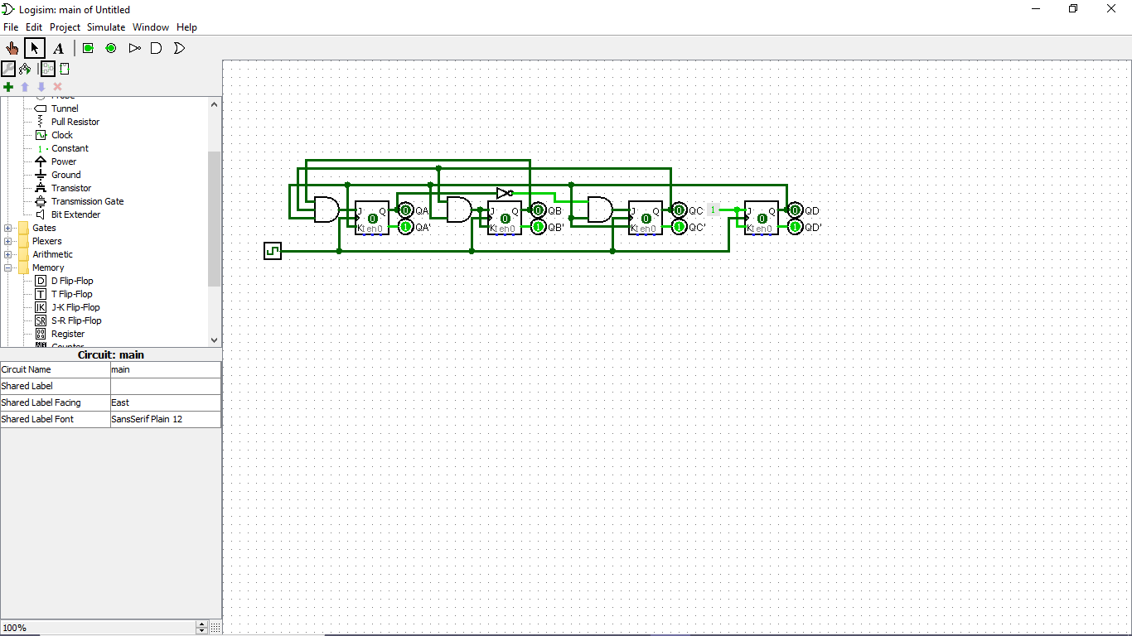KD(QA,QB,QC,QD)=1

**Question 2: Design 3-bit synchronous counter that counts 0 → 1 → 2 → 4 → 7 and back to zero. Also, when the counter starts from undefined state (i.e., states 3, 5, and 6), it jumps to state 0, and continues its operation.**

|  |  |  |  |  |  |  |  |  |  |  |  |
| --- | --- | --- | --- | --- | --- | --- | --- | --- | --- | --- | --- |
| QA | QB | QC | QA+ | QB+ | QC+ | JA | KA | JB | KB | JC | KC |
| 0 | 0 | 0 | 0 | 0 | 1 | 0 | x | 0 | x | 1 | x |
| 0 | 0 | 1 | 0 | 1 | 0 | 0 | x | 1 | x | x | 1 |
| 0 | 1 | 0 | 1 | 0 | 0 | 1 | x | x | 1 | 0 | x |
| 0 | 1 | 1 | 0 | 0 | 0 | 0 | x | x | 1 | x | 1 |
| 1 | 0 | 0 | 1 | 1 | 1 | x | 0 | 1 | x | 1 | x |
| 1 | 0 | 1 | 0 | 0 | 0 | x | 1 | 0 | x | x | 1 |
| 1 | 1 | 0 | 0 | 0 | 0 | x | 1 | x | 1 | 0 | x |
| 1 | 1 | 1 | 0 | 0 | 0 | x | 1 | x | 1 | x | 1 |

|  |  |  |  |  |
| --- | --- | --- | --- | --- |
| Qa\Qb Qc | 00 | 01 | 11 | 10 |
| 0 | 0 0 | 0 1 | 0 3 | 1 2 |
| 1 | x 4 | x 5 | x 7 | x 6 |

JA(QA,QB,QC)=QBQC’

|  |  |  |  |  |
| --- | --- | --- | --- | --- |
| Qa\Qb Qc | 00 | 01 | 11 | 10 |
| 0 | x 0 | x 1 | x 3 | x 2 |
| 1 | 0 4 | 1 5 | 1 7 | 1 6 |

KA(QA,QB,QC)=QBQC

|  |  |  |  |  |
| --- | --- | --- | --- | --- |
| Qa\Qb Qc | 00 | 01 | 11 | 10 |
| 0 | 0 0 | 1 1 | x 3 | x 2 |
| 1 | 1 4 | 0 5 | x 7 | x 6 |

JB(QA,QB,QC)=QA’QC+QAQC’

|  |  |  |  |  |
| --- | --- | --- | --- | --- |
| Qa\Qb Qc | 00 | 01 | 11 | 10 |
| 0 | x 0 | x 1 | 1 3 | 1 2 |
| 1 | x 4 | x 5 | 1 7 | 1 6 |

KB(QA,QB,QC)=1

|  |  |  |  |  |
| --- | --- | --- | --- | --- |
| Qa\Qb Qc | 00 | 01 | 11 | 10 |
| 0 | 1 0 | x 1 | x 3 | 0 2 |
| 1 | 1 4 | x 5 | x 7 | 0 6 |

JC(QA,QB,QC)=QB’

|  |  |  |  |  |
| --- | --- | --- | --- | --- |
| Qa\Qb Qc | 00 | 01 | 11 | 10 |
| 0 | x 0 | 1 1 | 1 3 | x 2 |
| 1 | x 4 | 1 5 | 1 7 | x 6 |

KC(QA,QB,QC)=1

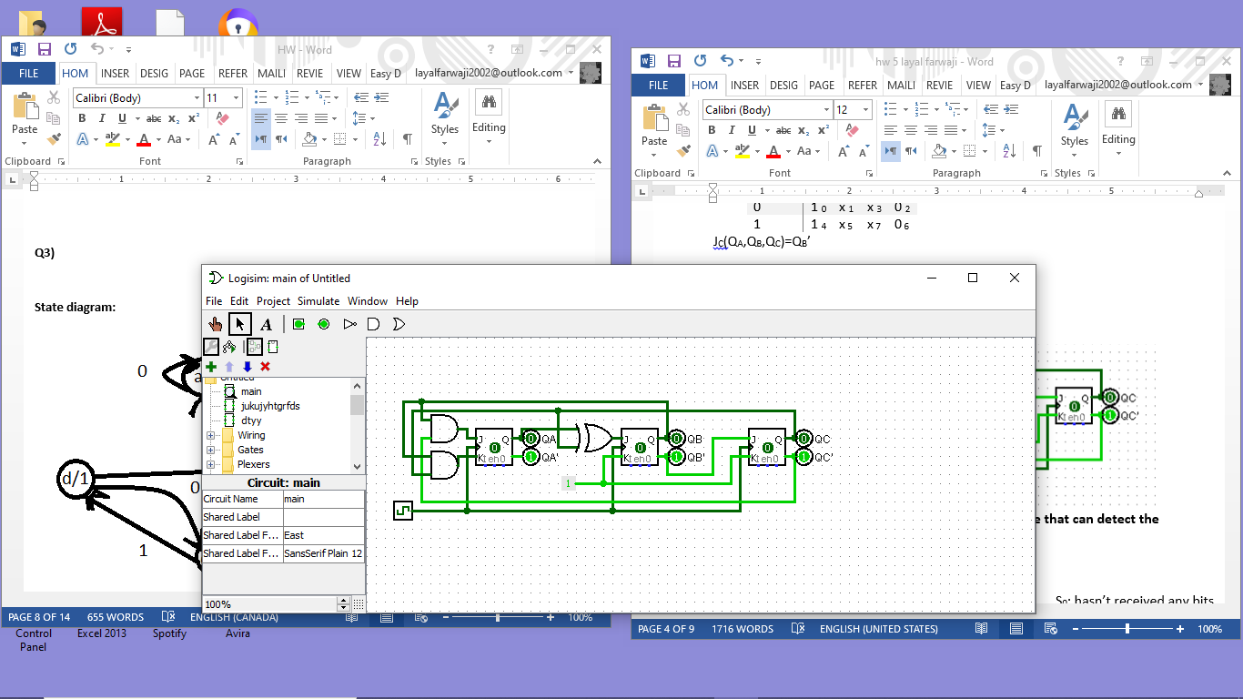

**Question 3: Design a sequence detector as a Moore machine that can detect the pattern 101 using D-flip flops.**

**(a) Build the state graph for the machine.**

S0; hasn’t received any bits  
S1; input sequence ending in “1”  
S2; input sequence ending in “10”  
S3; input sequence ending in “101”

X=0

X=1

X=1

X=0

X=0

X=1

X=0

X=1

**(b) Find the number of FFs required.**

log2(4)=2 flip-flops.

**(c) Build the state and the transition table of the machine and extend it to include the inputs of the FFs.**

|  |  |  |  |  |  |  |  |
| --- | --- | --- | --- | --- | --- | --- | --- |
| Present State | | Input | Next State | | Output | D Input | |
| QA | QB | X | QA+ | QB+ | Z | DA | DB |
| 0 | 0 | 0 | 0 | 0 | 0 | 0 | 0 |
| 0 | 0 | 1 | 0 | 1 | 0 | 0 | 1 |
| 0 | 1 | 0 | 1 | 0 | 0 | 1 | 0 |
| 0 | 1 | 1 | 0 | 1 | 0 | 0 | 1 |
| 1 | 0 | 0 | 0 | 0 | 0 | 0 | 0 |
| 1 | 0 | 1 | 1 | 1 | 0 | 1 | 1 |
| 1 | 1 | 0 | 1 | 0 | 1 | 1 | 0 |
| 1 | 1 | 1 | 0 | 1 | 1 | 0 | 1 |

**(d) Find the minimum SOP expression for each input of each flip-flop.**

|  |  |  |  |  |
| --- | --- | --- | --- | --- |
| Qa\Qb X | 00 | 01 | 11 | 10 |
| 0 | 0 0 | 0 1 | 0 3 | 1 2 |
| 1 | 0 4 | 1 5 | 0 7 | 1 6 |

DA(QA,QB,X)=QBX’+QAQB’X

|  |  |  |  |  |
| --- | --- | --- | --- | --- |
| Qa\Qb X | 00 | 01 | 11 | 10 |
| 0 | 0 0 | 1 1 | 1 3 | 0 2 |
| 1 | 0 4 | 1 5 | 1 7 | 0 6 |

D**B**(QA,QB,X)=X

|  |  |  |  |  |
| --- | --- | --- | --- | --- |
| Qa\Qb X | 00 | 01 | 11 | 10 |
| 0 | 0 0 | 0 1 | 0 3 | 0 2 |
| 1 | 0 4 | 0 5 | 1 7 | 1 6 |

Z(QA,QB,X)=QAQB

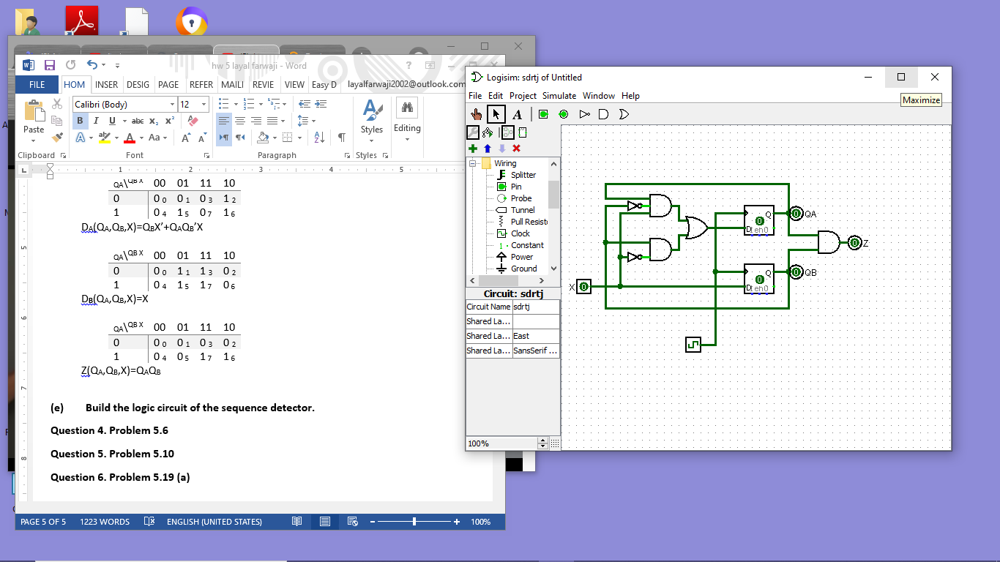**(e) Build the logic circuit of the sequence detector.**

**Question 4. Problem 5.6 Sequential circuit with 2 D-flip-flops A and B, two inputs x and y, and one output z has next-state and output equations**

**A(t+1)=xy’+xB  
B(t+1)=xA+xB’  
z=A**

1. **Draw the logic diagram**

Q(t+1)=D

DA=xy’+xB  
DB=xA+xB’

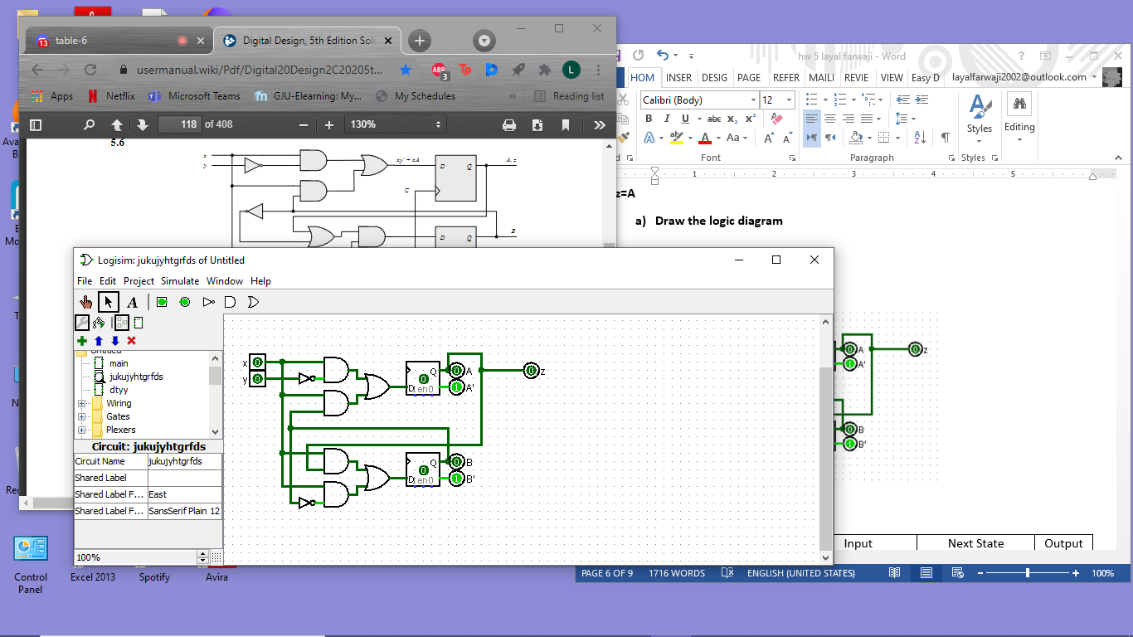

1. **List the state table**

|  |  |  |  |  |  |  |
| --- | --- | --- | --- | --- | --- | --- |
| Present State | | Input | | Next State | | Output |
| A | B | x | y | A(t+1) | B(t+1) | z |
| 0 | 0 | 0 | 0 | 0 | 0 | 0 |
| 0 | 0 | 0 | 1 | 0 | 0 | 0 |
| 0 | 0 | 1 | 0 | 1 | 1 | 0 |
| 0 | 0 | 1 | 1 | 0 | 1 | 0 |
| 0 | 1 | 0 | 0 | 0 | 0 | 0 |
| 0 | 1 | 0 | 1 | 0 | 0 | 0 |
| 0 | 1 | 1 | 0 | 1 | 0 | 0 |
| 0 | 1 | 1 | 1 | 1 | 0 | 0 |
| 1 | 0 | 0 | 0 | 0 | 0 | 1 |
| 1 | 0 | 0 | 1 | 0 | 0 | 1 |
| 1 | 0 | 1 | 0 | 1 | 1 | 1 |
| 1 | 0 | 1 | 1 | 0 | 1 | 1 |
| 1 | 1 | 0 | 0 | 0 | 0 | 1 |
| 1 | 1 | 0 | 1 | 0 | 0 | 1 |
| 1 | 1 | 1 | 0 | 1 | 1 | 1 |
| 1 | 1 | 1 | 1 | 1 | 1 | 1 |

1. **Draw the state diagram**

|  |  |  |  |  |
| --- | --- | --- | --- | --- |
| Present State | Input | | Next State | Output |
| S | x | y | S+ | z |
| S0 | 0 | 0 | S0 | 0 |
| S0 | 0 | 1 | S0 | 0 |
| S0 | 1 | 0 | S3 | 0 |
| S0 | 1 | 1 | S1 | 0 |
| S1 | 0 | 0 | S0 | 0 |
| S1 | 0 | 1 | S0 | 0 |
| S1 | 1 | 0 | S2 | 0 |
| S1 | 1 | 1 | S2 | 0 |
| S2 | 0 | 0 | S0 | 1 |
| S2 | 0 | 1 | S0 | 1 |
| S2 | 1 | 0 | S3 | 1 |
| S2 | 1 | 1 | S1 | 1 |
| S3 | 0 | 0 | S0 | 1 |
| S3 | 0 | 1 | S0 | 1 |
| S3 | 1 | 0 | S3 | 1 |
| S3 | 1 | 1 | S3 | 1 |

00/0

01/0

10/0

11/0

11/0

00/0

01/0

10/1

11/1

01/1

00/1

11/1

00/1

01/1

10/1

10/0

**Question 5. Problem 5.10 Sequential circuit with 2 J-K flip-flops A and B, two inputs x and y, and one output z has flip-flop input equations and circuit output equation**

**JA=Bx+B’y’  
KA=B’xy’  
JB=A’x  
KB=A+xy’  
z=Ax’y’+Bx’y’**

1. **Draw logic diagram**

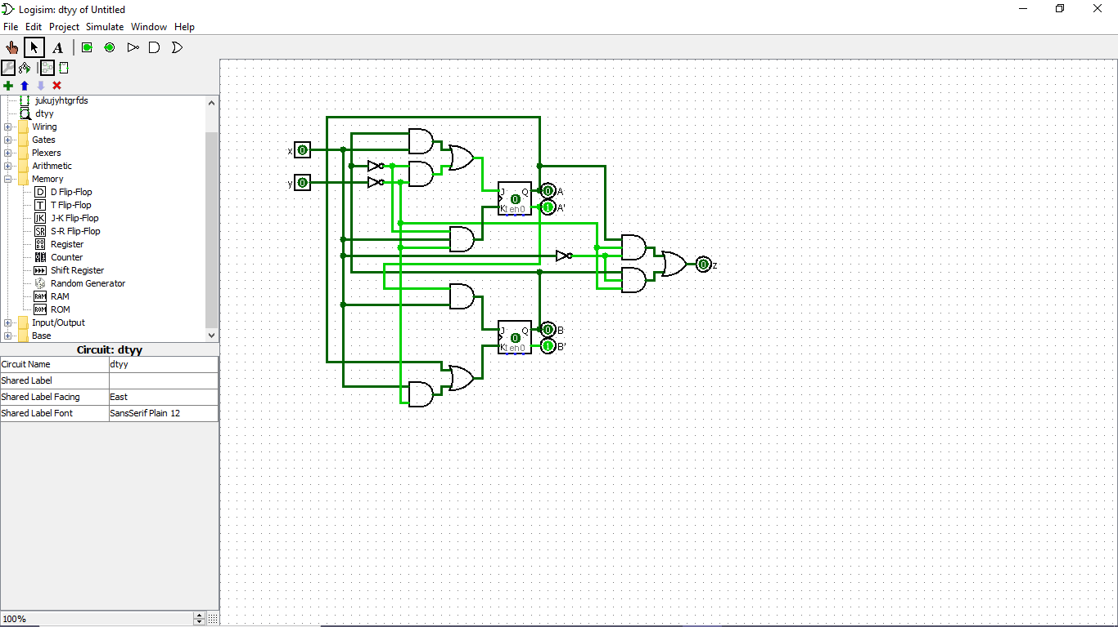

1. **Tabulate state table**

|  |  |  |  |  |  |  |
| --- | --- | --- | --- | --- | --- | --- |
| Present State | | Input | | Next State | | Output |
| A | B | x | y | A(t+1) | B(t+1) | z |
| 0 | 0 | 0 | 0 | 1 | 0 | 0 |
| 0 | 0 | 0 | 1 | 0 | 0 | 0 |
| 0 | 0 | 1 | 0 | 1 | 1 | 0 |
| 0 | 0 | 1 | 1 | 0 | 1 | 0 |
| 0 | 1 | 0 | 0 | 0 | 1 | 1 |
| 0 | 1 | 0 | 1 | 0 | 1 | 0 |
| 0 | 1 | 1 | 0 | 1 | 0 | 0 |
| 0 | 1 | 1 | 1 | 1 | 1 | 0 |
| 1 | 0 | 0 | 0 | 1 | 0 | 1 |
| 1 | 0 | 0 | 1 | 1 | 0 | 0 |
| 1 | 0 | 1 | 0 | 0 | 0 | 0 |
| 1 | 0 | 1 | 1 | 1 | 0 | 0 |
| 1 | 1 | 0 | 0 | 1 | 0 | 1 |
| 1 | 1 | 0 | 1 | 1 | 0 | 0 |
| 1 | 1 | 1 | 0 | 1 | 0 | 0 |
| 1 | 1 | 1 | 1 | 1 | 0 | 0 |

1. **Derive state equations for A and B**

A(t+1)=JAA’+KA’A

=(Bx+B’y’)A’+(B’xy’)’A

=(Bx+B’y’)A’+(B+x’+y)A

B(t+1)=JBB’+KB’B  
 =(A’x)B’+(A+xy’)’B

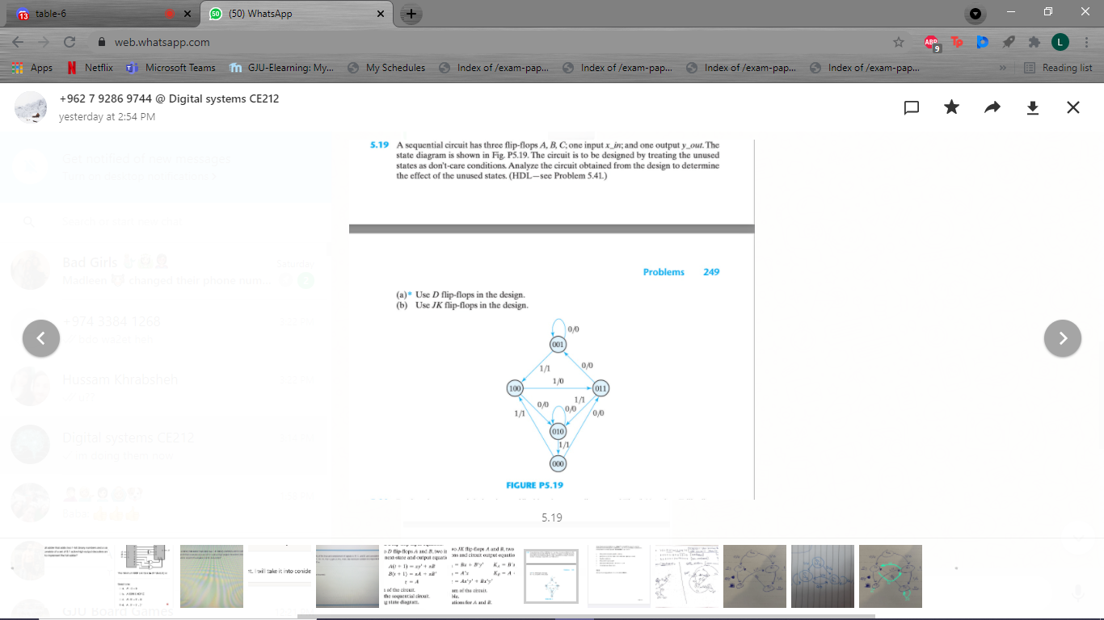**Question 6. Problem 5.19 (a) Sequential circuit has 3 D flip-flops A,B,C, one input x_in, and one output y_out. State diagram is below. Treat unused states as don’t care. Analyze the circuit obtained from design to determine the effect of the unused states.**

|  |  |  |  |  |  |  |  |  |  |  |
| --- | --- | --- | --- | --- | --- | --- | --- | --- | --- | --- |
| Present State | | | Input | Next State | | | Output | D-input | | |
| A | B | C | x | A+ | B+ | C+ | y | DA | DB | DC |
| 0 | 0 | 0 | 0 | 0 | 1 | 1 | 0 | 0 | 1 | 1 |
| 0 | 0 | 0 | 1 | 1 | 0 | 0 | 1 | 1 | 0 | 0 |
| 0 | 0 | 1 | 0 | 0 | 0 | 1 | 0 | 0 | 0 | 1 |
| 0 | 0 | 1 | 1 | 1 | 0 | 0 | 1 | 1 | 0 | 0 |
| 0 | 1 | 0 | 0 | 0 | 1 | 0 | 0 | 0 | 1 | 0 |
| 0 | 1 | 0 | 1 | 0 | 0 | 0 | 1 | 0 | 0 | 0 |
| 0 | 1 | 1 | 0 | 0 | 0 | 1 | 0 | 0 | 0 | 1 |
| 0 | 1 | 1 | 1 | 0 | 1 | 0 | 1 | 0 | 1 | 0 |
| 1 | 0 | 0 | 0 | 0 | 1 | 0 | 0 | 0 | 1 | 0 |
| 1 | 0 | 0 | 1 | 0 | 1 | 1 | 0 | 0 | 1 | 1 |

|  |  |  |  |  |
| --- | --- | --- | --- | --- |
| A B\C x | 00 | 01 | 11 | 10 |
| 00 | 0 0 | 1 1 | 1 3 | 0 2 |
| 01 | 0 4 | 0 5 | 0 7 | 0 6 |
| 11 | x 12 | x 13 | x 15 | x 14 |
| 10 | 0 8 | 0 9 | x 11 | x 10 |

DA(A,B,C,x)=A’B’x

values of ∑d(10,11,12,13,14,15)=0

|  |  |  |  |  |
| --- | --- | --- | --- | --- |
| A B\C x | 00 | 01 | 11 | 10 |
| 00 | 1 0 | 0 1 | 0 3 | 0 2 |
| 01 | 1 4 | 0 5 | 1 7 | 0 6 |
| 11 | x 12 | x 13 | x 15 | x 14 |
| 10 | 1 8 | 1 9 | x 11 | x 10 |

DB(A,B,C,x)=A+C’x’+BCx

values of ∑d(10,11,12,13,14,15)=1

|  |  |  |  |  |
| --- | --- | --- | --- | --- |
| A B\C x | 00 | 01 | 11 | 10 |
| 00 | 1 0 | 0 1 | 0 3 | 1 2 |
| 01 | 0 4 | 0 5 | 0 7 | 1 6 |
| 11 | x 12 | x 13 | x 15 | x 14 |
| 10 | 0 8 | 1 9 | x 11 | x 10 |

DC(A,B,C,x)=Ax+Cx’+A’B’x’

values of ∑d(10,11,13,14,15)=1  
 value of ∑d(12)=0

|  |  |  |  |  |
| --- | --- | --- | --- | --- |
| A B\C x | 00 | 01 | 11 | 10 |
| 00 | 0 0 | 1 1 | 1 3 | 0 2 |
| 01 | 0 4 | 1 5 | 1 7 | 0 6 |
| 11 | x 12 | x 13 | x 15 | x 14 |
| 10 | 0 8 | 0 9 | x 11 | x 10 |

y(A,B,C,x)=A’x

0/0  
1/0

1/0

0/0

0/0  
1/0